**QUESTION NO-01**

<!DOCTYPE html>

<html lang="en">

<head>

    <meta charset="UTF-8">

    <meta name="viewport" content="width=device-width, initial-scale=1.0">

    <title>Core  HTML</title>

</head>

<body>

 <p>

    <b>This text will be bolderd</b>

 </p>

 <p>

    <i>This text will be italic</i>

 </p>

 <p>

    <ins>This text will be underlined</ins>

 </p>

 <p>

    <mark>This text will be highlighted</mark>

 </p>

 <p>

    This is normal text<sup>This will be super scripted</sup>This is normal again

 </p>

 <p>

    This is normal text <small>small text</small>

 </p>

 <p><del>This text will be deleted</del></p>

</body>

</html>

OUTPUT:-

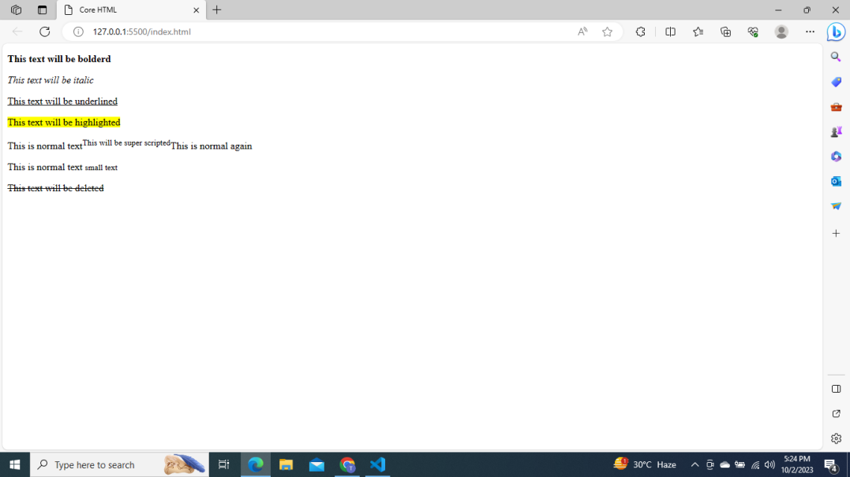

**QUESTION NO-02**

<!DOCTYPE html>

<html lang="en">

<head>

    <meta charset="UTF-8">

    <meta name="viewport" content="width=device-width, initial-scale=1.0">

    <title>Document</title>

</head>

<body>

    <h1>Navigate me</h1>

    <p>

        Take to me

        <a href="https://pwskills.com/" target="-blank">PW SKILLS</a> to buy a course

    </p>

    <p>

        Take to me

        <a href="https://www.w3schools.com/html/default.asp" target="-blank">W3 schools</a> to learn HTML through this website

    </p>

    <p>

        Take to me

        <a href="https://www.javatpoint.com/" target="-blank">javatpoint</a> to learn HTML through javatpoint

    </p>

</body>

</html>

Output:-

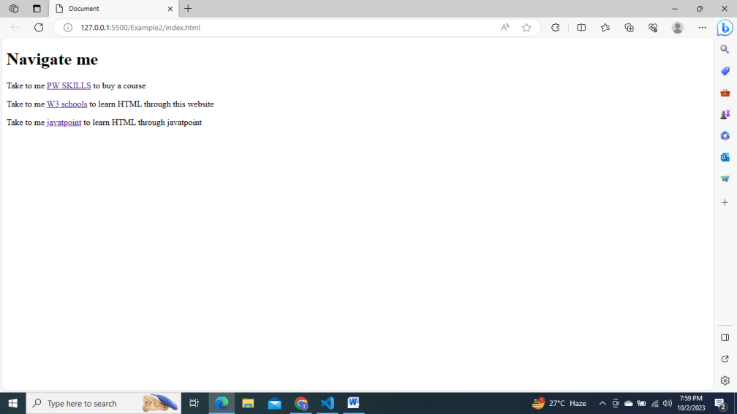

Home.html

<!DOCTYPE html>

<html lang="en">

<head>

    <meta charset="UTF-8">

    <meta name="viewport" content="width=device-width, initial-scale=1.0">

    <title>Home page</title>

</head>

<body>

    <div>

        <a href="./home.html">Home </a>|

        <a href="./WebDevelopment.html">Web Develoment</a>|

        <a href="./WebDesign.html">Web Design</a>|

    </div>

    <div>

        <h1>Home Page</h1>

        <p>

            Web design is a multifaceted field that involves the planning, creation,<br>

            and maintenance of websites. It encompasses a variety of skills and disciplines,<br>

             including graphic design, user interface (UI) design, user experience (UX) design,<br>

              coding, and content creation.

            <br>

            Web design is a multifaceted field that involves the planning, creation,<br>

            and maintenance of websites. It encompasses a variety of skills and disciplines, <br>

            including graphic design, user interface (UI) design, user experience (UX) design,<br>

             coding, and content creation.

        </p>

    </div>

</body>

</html>

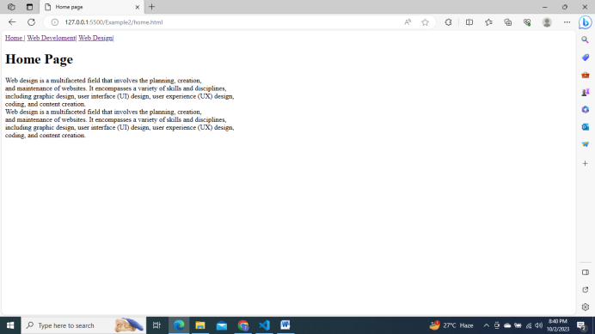

WebDevelopment.html

<!DOCTYPE html>

<html lang="en">

<head>

    <meta charset="UTF-8">

    <meta name="viewport" content="width=device-width, initial-scale=1.0">

    <title>webDevlopment</title>

</head>

<body>

    <div>

        <a href="./home.html">Home |</a>

        <a href="./WebDevelopment.html">Web Develoment |</a>

        <a href="./WebDesign.html">Web Design |</a>

    </div>

    <div>

        <h1>Web Develoment</h1>

        <p>

            Lorem ipsum dolor sit amet  consectetur adipisicing elit. Corrupti dignissimos expedita

            <br>

            harum qui impedit maxime quis doloremque quos vel ipsam, dolor quaerat velit

             ipsa esse, quidem tempore. Impedit, expedita.

        </p>

    </div>

</body>

</html>

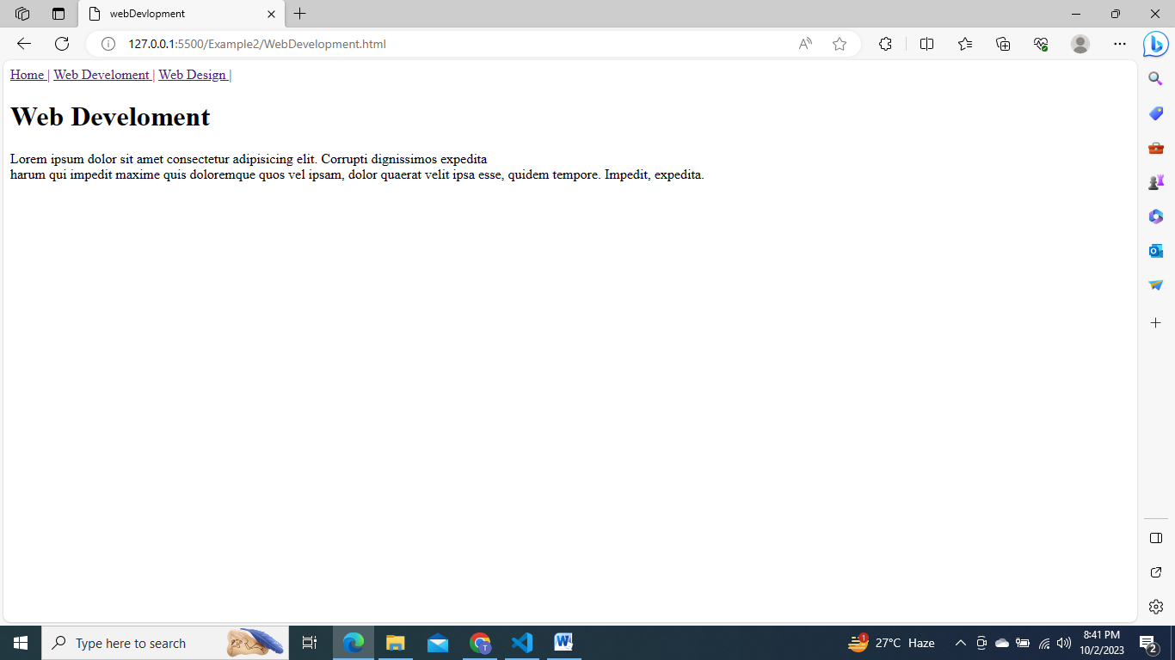

webDesign.html

<!DOCTYPE html>

<html lang="en">

<head>

    <meta charset="UTF-8">

    <meta name="viewport" content="width=device-width, initial-scale=1.0">

    <title>web Design</title>

</head>

<body>

    <div>

        <a href="./home.html">Home |</a>

        <a href="./WebDevelopment.html">Web Develoment |</a>

        <a href="./WebDesign.html">Web Design |</a>

    </div>

    <div>

        <h1>Web Design</h1>

        <p>

            Lorem ipsum dolor sit amet  consectetur adipisicing elit. Corrupti dignissimos expedita

            <br>

            harum qui impedit maxime quis doloremque quos vel ipsam, dolor quaerat velit

             ipsa esse, quidem tempore. Impedit, expedita.

        </p>

    </div>

</body>

</html>

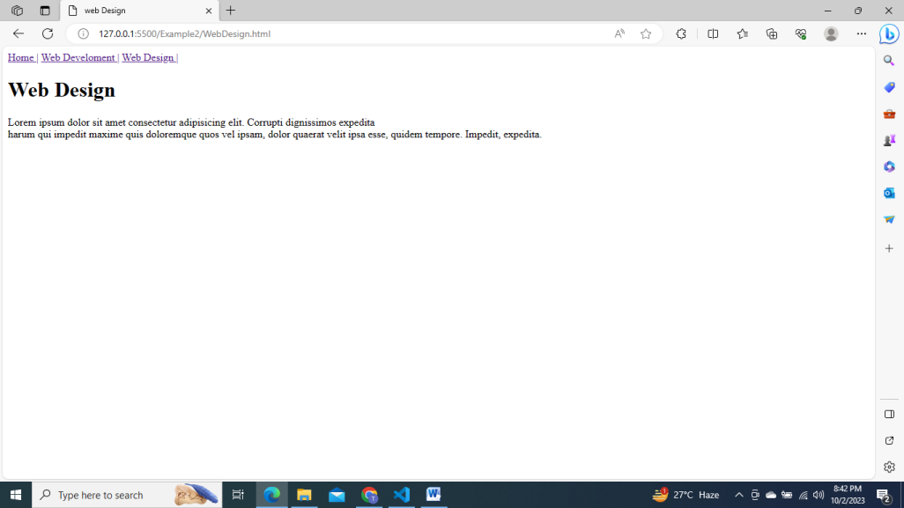

**QUESTION NO-04**

<!DOCTYPE html>

<html lang="en">

<head>

    <meta charset="UTF-8">

    <meta name="viewport" content="width=<device-width>, initial-scale=1.0">

    <title>Document</title>

</head>

<body>

    <h1>List of Tags</h1>

    <ol>

        <li>h1: Defines a heading level-1</li>

        <li>p: Defines a paragaraph of text</li>

        <li>div: Defines the container for HTML elements</li>

        <li>table: Defines a table with rows and columns</li>

        <li>ul: Defines an unordered list </li>

    </ol>

</body>

</html>

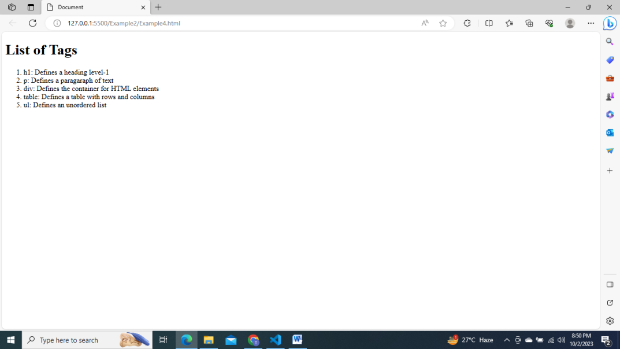

**QUESTION NO-05**

<!DOCTYPE html>

<html lang="en">

<head>

    <meta charset="UTF-8">

    <meta name="viewport" content="width=device-width, initial-scale=1.0">

    <title>Document</title>

</head>

<body>

    <h1>Full Stack Web Development Tech Stack: </h1>

    <dl>

        <dt>HTML:-</dt>

        <dd>

            HyperText Markup Language is the standard markup language for creating

            web pages and other online documents.

        </dd>

        <dt>CSS:-</dt>

        <dd>

            CSS is the language we use to style a Web page

        </dd>

        <dt>JavaScript:-</dt>

        <dd>

            JavaScript is a programming language used to create interactive effects

            within web browsers.

        </dd>

        <dt>Node.js:-</dt>

        <dd>

            Node.js is an open-source, cross-platform, JavaScript runtime

            environment that executes JavaScript code outside of a browser.

        </dd>

        <dt>Express.js:-</dt>

        <dd>

            Express.js is a web application framework for Node.js designed for

            building web applications and APIs.

        </dd>

        <dt>MongoDB:-</dt>

        <dd>

            MongoDB is a NoSQL document-oriented database program that uses

JSON-like documents with optional schemas.

        </dd>

        <dt>React.js:-</dt>

        <dd>

            React.js is a JavaScript library for building user interfaces or UI

            components.

        </dd>

    </dl>

</body>

</html>

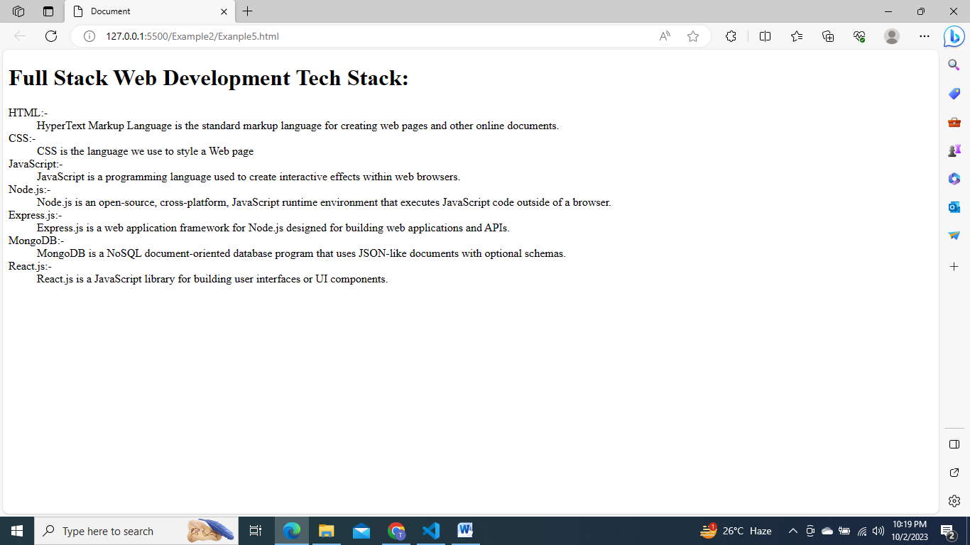

**QUESTION MO-06**

<!DOCTYPE html>

<html lang="en">

  <head>

    <meta charset="UTF-8" />

    <meta name="viewport" content="width=device-width, initial-scale=1.0" />

    <title>Document</title>

  </head>

  <body>

    <ol>

        <!-- Starting about HTML -->

      <li>

        <h2>HTML</h2>

        <table border="1">

          <tr>

            <th>Primary Use Cases</th>

            <th>Key Features/Benefits</th>

          </tr>

          <tr>

            <td>Building the structure of web pages</td>

            <td>

              <ul>

                <li>Simple and easy to learn</li>

                <li>Compatible with all web browsers</li>

                <li>Allows for semantic markup</li>

              </ul>

            </td>

          </tr>

        </table>

      </li>

      <!-- Ending about HTML -->

      <li>

        <h2>CSS</h2>

        <table border="1">

          <tr>

            <th>Primary Use Cases</th>

            <th>Key Features/Benefits</th>

          </tr>

          <tr>

            <td>Styling and layout of web pages</td>

            <td>

              Full Stack Web Development

              <ul>

                <li>Allows for separation of content and presentation</li>

                <li>Enables responsive design</li>

                <li>Offers a wide range of styling options</li>

              </ul>

            </td>

          </tr>

        </table>

      </li>

      <!-- Ending CSS -->

      <li>

        <h2>JavaScript</h2>

        <table border="1">

          <tr>

            <th>Primary Use Cases</th>

            <th>Key Features/Benefits</th>

          </tr>

          <tr>

            <td>Adding interactivity and functionality to web pages</td>

            <td>

              <ul>

                <li>Can manipulate and modify web page content in real-time</li>

                <li>

                  Offers a wide range of functionality through libraries and

                  frameworks

                </li>

                <li>Allows for server-side scripting with Node.js</li>

              </ul>

            </td>

          </tr>

        </table>

      </li>

      <!-- Ending JavaScript -->

    </ol>

  </body>

</html>

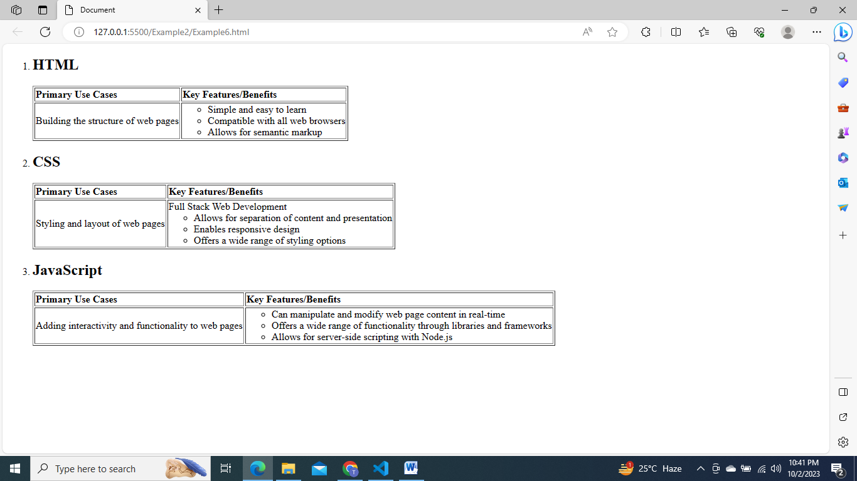

**QUESTION NO-7**

<!DOCTYPE html>

<html lang="en">

  <head>

    <meta charset="UTF-8" />

    <meta name="viewport" content="width=device-width, initial-scale=1.0" />

    <title>Document</title>

  </head>

  <body>

    <h1>Table of contents</h1>

    <ul>

      <li><a href="#">Part 1: Introduction</a></li>

      <li>

        <a href="#">Part 2: Getting Started</a>

        <ul>

          <li><a href="#">2.1 Installing the Software</a></li>

          <li>

            <a href="#">2.2 Creating a New Project</a>

            <ul>

              <li><a href="#">2.2.1 Project Templates</a></li>

              <li><a href="#">2.2.2 Customizing Settings</a></li>

            </ul>

          </li>

          <li>

            <a href="#">2.3 Exploring the Interface</a>

            <ul>

              <li><a href="#">2.3.1 Toolbar Features</a></li>

              <li>

                <a href="#">2.3.2 Panel Layout</a>

                <ul>

                  <li><a href="#">2.3.2.1 Docking Panels</a></li>

                  <li><a href="#">2.3.2.2 Tabbed Interface</a></li>

                </ul>

              </li>

            </ul>

          </li>

        </ul>

      </li>

      <li>

        <a href="#">Part 3: Advanced Topics</a>

        <ul>

          <li>

            <a href="#">3.1 Working with Plugins</a>

            <ul>

              <li><a href="#">3.1.1 Installing Plugins</a></li>

              <li><a href="#">3.1.2 Plugin Configuration</a></li>

            </ul>

          </li>

          <li>

            <a href="#">3.2 Customizing the UI</a>

            <ul>

              <li><a href="#">3.2.1 Changing Themes</a></li>

              <li><a href="#">3.2.2 Configuring Shortcuts</a></li>

            </ul>

          </li>

          <li>

            <a href="#">3.3 Optimizing Performance</a>

            <ul>

              <li><a href="#">3.3.1 Caching Strategies</a></li>

              <li><a href="#">3.3.2 Resource Minification</a></li>

            </ul>

          </li>

        </ul>

      </li>

      <li><a href="#">Part 7: Conclusion</a></li>

    </ul>

  </body>

</html>

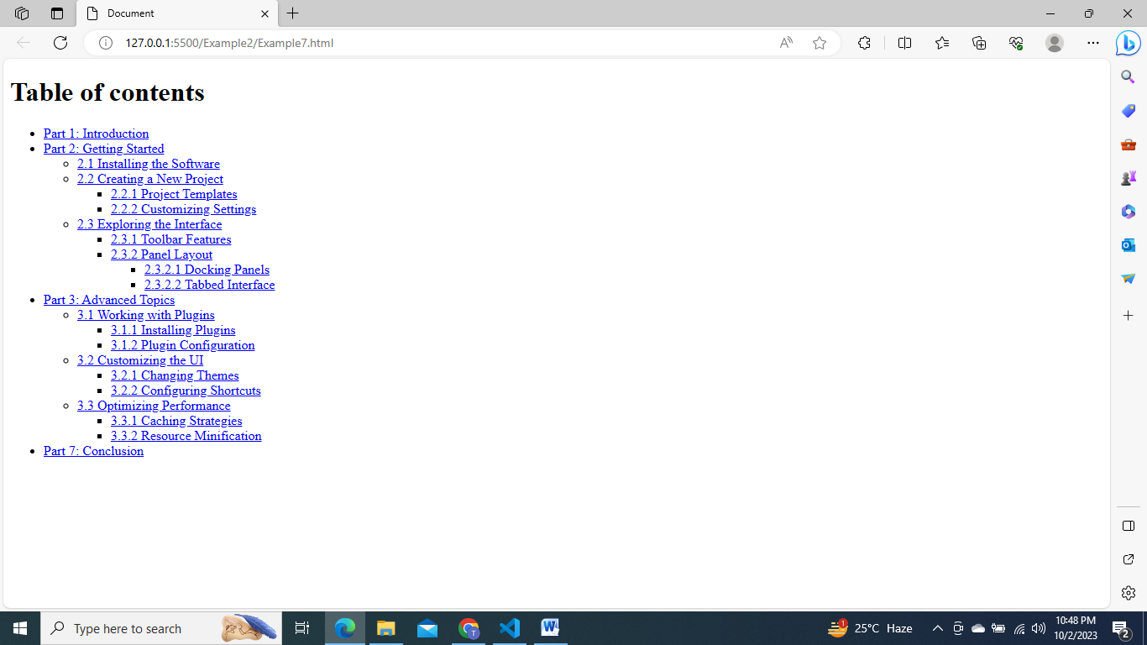

**QUESTION NO:-8**

<!DOCTYPE html>

<html lang="en">

  <head>

    <meta charset="UTF-8" />

    <meta name="viewport" content="width=device-width, initial-scale=1.0" />

    <title>Document</title>

  </head>

  <body>

    <h1>Conference Schedule</h1>

    <table border="1" cellpadding="10">

      <thead>

        <tr>

          <th>Time</th>

          <th>Room 1</th>

          <th>Room 2</th>

          <th>Room 3</th>

          <th>Room 4</th>

        </tr>

      </thead>

      <tbody>

        <tr>

          <td rowspan="3">9:00 AM - 10:00 AM</td>

          <td rowspan="2">Keynote</td>

          <td>Session A</td>

          <td>Session B</td>

          <td rowspan="3">Session C</td>

        </tr>

        <tr>

          <td>Session D</td>

          <td>Session E</td>

        </tr>

        <tr>

          <td>10:30 AM - 11:30 AM</td>

          <td colspan="2">Session F</td>

        </tr>

        <tr>

          <td>12:00 PM - 1:00 PM</td>

          <td colspan="4">Lunch Break</td>

        </tr>

        <tr>

          <td rowspan="2">1:00 PM - 2:00 PM</td>

          <td>Session G</td>

          <td rowspan="2">Session H</td>

          <td>Session I</td>

          <td>Session J</td>

        </tr>

        <tr>

          <td>Session K</td>

          <td>Session L</td>

          <td>Session M</td>

        </tr>

      </tbody>

    </table>

  </body>

</html>

